**TRANSACTION MANAGEMENT APP**

**Introduction**: In a fast-paced world where multiple payment methods are deployed, individuals and businesses often struggle to track and manage their financial transactions efficiently, whether it be through cash, card or via online. The Transaction Management App is specifically designed to address this issue by providing a comprehensive solution for tracking, categorizing, and analyzing day-to-day financial transactions.

This project involves creating a Transaction Management (TM) app that computes daily transactions and compiles weekly summaries. It aids users in recalling payment details, including the purpose and date, while also enabling them to monitor their budget and avoid excessive spending.

**Overview:** The TM app takes input from the user, stores, and tracks the transaction. It also shows through a bar chart the user’s daily spending across the week. Users can also delete transactions using the Bin icon on the right of the transaction.

The virtual android phone is displayed using Android Studio and the code is done using **Flutter** and **Dart**.

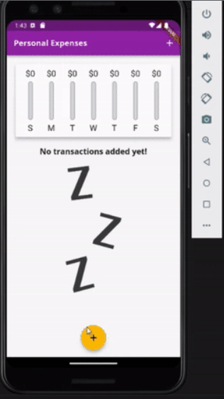

**Features:**

* **Transaction Recording:** Users can record their income and expenses, specifying the date, amount, category, and payment method.
* **Categories:** Transactions can be categorized into predefined or custom categories (e.g., groceries, entertainment, rent).
* **Charts and Graphs:** The app will generate visual representations of spending patterns, allowing users to view daily spending.
* **Date and Calendar:** This feature allows users to input transactions from previous days in case the user has missed recording the transaction on the day of spending.
* **Deleting Transactions:** The app includes a "discard" button that allows users to delete a transaction in case of incorrect input or for any other reason.

**Implementation:** To prevent cluttering of code in a single file, I have opted to organize Dart code into separate files for each feature. The main file serves as the entry point for running the app, containing the app bar design, the initial screen layout (shown in Figure 1), and functions to invoke various features. These features are implemented in their respective Dart files, with the main file referencing and calling them as needed.

The additional Dart files encompass specific functionality for managing new transactions and handling the chart bar. In the new transaction Dart file, the code is for designing the user input form. This form enables the user to input transaction details, including selecting a title, specifying an amount, and choosing a transaction date (as depicted in Figure 2).

On the other hand, the chart bar Dart file contains code that dynamically updates the chart bar in response to changes in transaction. This ensures that the chart bar reflects changes when new transactions are added, or previous ones are deleted (as illustrated in Figure 3).

**Conclusion**: The Transaction Management App aims to simplify and enhance the way individuals and businesses track and manage their financial transactions. By offering user-friendly features and robust security measures, it provides a comprehensive solution to address the challenges posed by the diverse payment methods in today's world. This app has the potential to greatly improve financial transparency and control for its users.

Author: Rohit Lahori